

**ANL252**

**Python For Data Analytics**

**End-of-Course Assessment (ECA)**

**July 2021 Presentation**

**Submitted by:**

|  |  |
| --- | --- |
| **Name** | **PI No.** |
| **LOO CHENKAI** | **Y2071132** |

**Submission Date:** 29 August 2021

**Question 1**

**Q1 A(i)**

# #Q1 A(i)

# Load pandas

import pandas as pd

import numpy as np

# Read CSV file into DataFrame df

ship = pd.read_csv(r'ship.csv', index_col=0)

#replace . with "no value"

ship = ship.replace(".", 'no value').reset_index()

# Show dataframe

ship

**Screenshot for Q1Ai:**

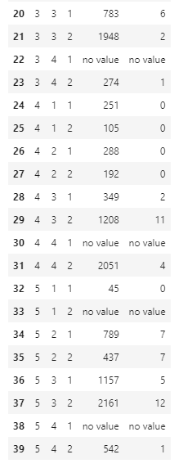

**Q1A(ii)**

ship = ship.set_axis(['type','c_years','o_period','s_months','incidents'], axis=1)

ship.columns

**Screenshot for Q1A(ii):**





**Q1 A(iii)**

#Makes table of average of cross product of categories

table = list()

for i in range(5):

cur1 = pd.DataFrame(ship.loc[(ship['type'] == i+1)]['incidents'])

cur1_ = pd.DataFrame(ship.loc[(ship['type'] == i+1)]['o_period'])

for j in range(2):

table.append([])

cur2 = ship.loc[(ship['o_period'] == j+1)]['incidents']

cur2_ = ship.loc[(ship['o_period'] == j+1)]['o_period']

mean = np.mean(np.mean(cur1.merge(cur2, how='cross').astype(int)))

mean_ = np.mean(np.mean(cur1_.merge(cur2_, how='cross').astype(int)))

table[-1].append(i)

table[-1].append(j)

table[-1].append(mean)

table[-1].append(mean_)

shipgroup = pd.DataFrame(table)

shipgroup.columns = ['type','o_period','incidents','o_period']

shipgroup

**Screenshot for Q1A(iii):**

**Q1 A(iv)**

#iterates through ship to find where s_months and icidents is "no_value"

missing_df = ship.loc[(ship['s_months'] == "no value")]

for i in range(len(missing_df)):

#Find rows where data is missing

missing = (int(missing_df['type'][i:i+1]),int(missing_df['o_period'][i:i+1]))

a = ship.loc[ship['type'] == missing[0]]

a = a.loc[a['o_period'] == missing[1]]

a = a.loc[a['s_months'] != "no value"]

#gets average of datapoints with same o_period and type values and updates dataframe

av = sum(list(map(int, list(a['incidents']))))/len(a)

ship['incidents'] = ship.mask((ship['o_period'] == missing[1]) & (ship['type'] == missing[0]) & (ship['incidents'] == "no value"), av)['incidents']

#does same update to s_months

av = sum(list(map(int, list(a['s_months']))))/len(a)

ship['s_months'] = ship.mask((ship['o_period'] == missing[1]) & (ship['type'] == missing[0]) & (ship['s_months'] == "no value"), av)['s_months']

ship

**Screenshot for Q1A(iv):**

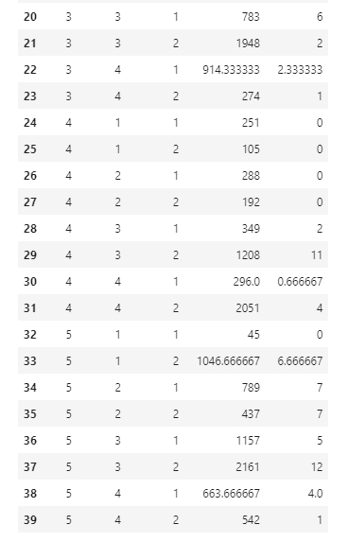

**Q1 A(v)**

Y = ship['incidents'].astype("float")

Y

**Screenshot for Q1 A(v):**



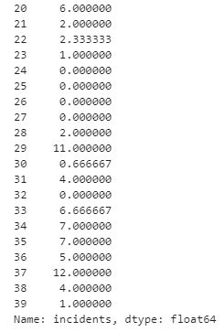

**Q1 B(i)**

I

#turn column types into categories

ship['type'] = ship['type'].astype("category")

ship['c_years'] = ship['c_years'].astype("category")

ship['o_period'] = ship['o_period'].astype("category")

ship['s_months'] = ship['s_months'].astype("int")

**Screenshot for Q1B(i):**

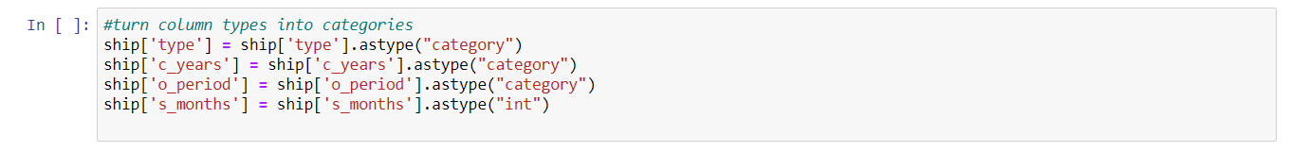

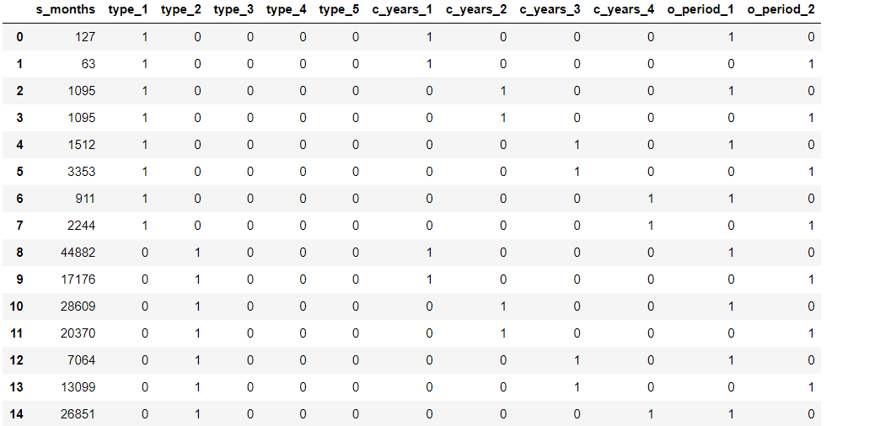

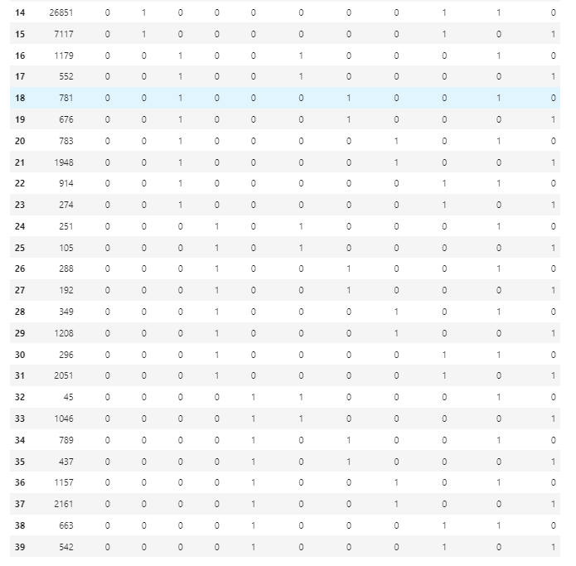

**Q1 B(ii)**

#get dummy variables

X = ship.copy()

X = pd.get_dummies(ship, columns=['type','c_years','o_period'])

del X['incidents']

X

**Screenshot for Q1B(ii):**

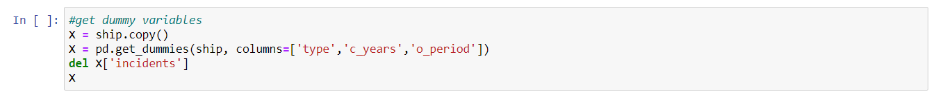

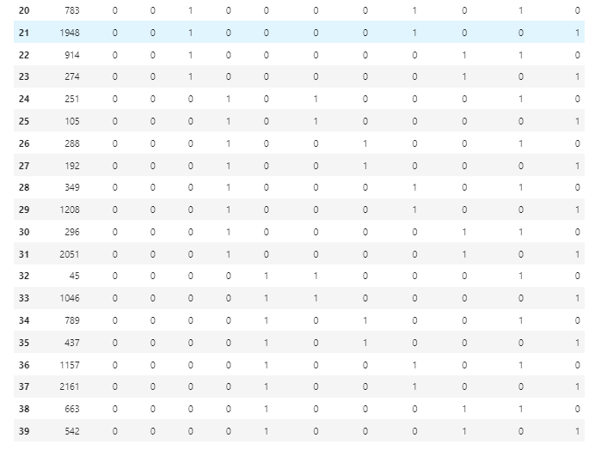

**Q1 B(iii)**

log_s_months = np.log(X['s_months'].astype(float))

X.insert(1, 'log_s_months', log_s_months)

ship.insert(1, 'log_s_months', log_s_months)

X

**Screenshot:**



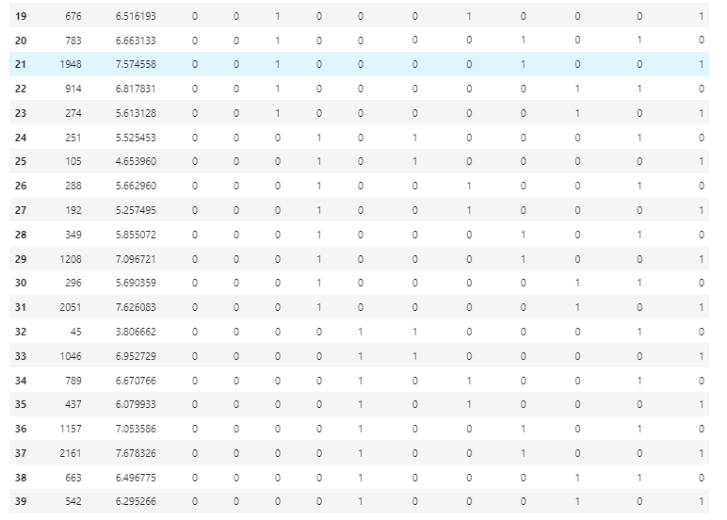

**Q1(C)**

This dataset is unusually small. It contains only 39 datapoints. One downside to this is that there is a chance that this dataset is biased. Splitting this into a training and testing set will only make this issue worse by further shrinking it. Doing a traditional 80-20 split will make the dataset only 32 points and make the data even more reliable. And when testing a model, it is important for the testing set to be unbiased as well, but the testing set will only contain around 7 points, drastically reducing the reliability of it.

**Q1(D)**

from sqlalchemy import create_engine

engine = create_engine('sqlite://', echo=False)

#Save dataframe as csv

ship.to_csv('shipdf.csv')

#Save dataframe as db file

ship.to_sql('shipdb.db', con=engine)

**Screenshot for Q1D:**

**Question 2**

**Q2 A)**

The Sklearn.linear_model.PoissonRegressor class is one which can create a poisson regression model. In order to train this model on any data, the fit() function must be used. The input and output is passed to this function, and the model calculates its coefficients given the data. Predict() is used once the model is fitted onto the dataset. It takes in data and returns an estimation of the correct output.

**Q2 B)**

from sklearn import linear_model

from sklearn import preprocessing

#Normalize Data

X_ = (X-X.mean())/X.std()

#Fit model to data

reg = linear_model.PoissonRegressor(max_iter = 1000000)

reg.fit(X_, Y)

reg.coef_

**Screenshot for Q2B:**

**Q2 C)**

#create function to calculate deviance

def dev(y, y_hat):

s = y * np.log(y/y_hat) - (y - y_hat)

return np.sum(s) * 2

dev(Y,reg.predict(X_))

**Screenshot for Q2C:**



**Embed Jupyter file:**



**Screenshot of all codes:**

